What is CSS?
- Cascading Style Sheet – A language for styling HTML documents.
- It specifies certain rules for layout and display of HTML elements.
- CSS uses key/value pairs to indicate the styling to apply.
- Style Sheets are a simple but powerful way of changing how our HTML document is rendered to make it more pleasant to look at.
- CSS is broken down into selectors and declarations
  - Selector: Defines the HTML element(s) you are styling.
  - Declaration: Defines the style you are imposing on the selector.

Where can we put the CSS?
- There are three places you can declare CSS styling
  - External Style Sheets (this tends to be best practice)
    - A separate CSS document that you link in your HTML
  - Initially in the <head> (pretty uncommon)
  - Inline of the actual HTML element tag (not best practice but easy and ok to do in a pinch)
- In case of conflicts? What if you’re trying to style the same element in multiple declarations?
  - The CSS closest to the element will “win” in conflicts
    - So inline styling beats head styling which beats external style sheets

CSS Box Model
- CSS treats each HTML element in the document as a “box”. Each box has its own 4 regions that can be styled independently of one another.
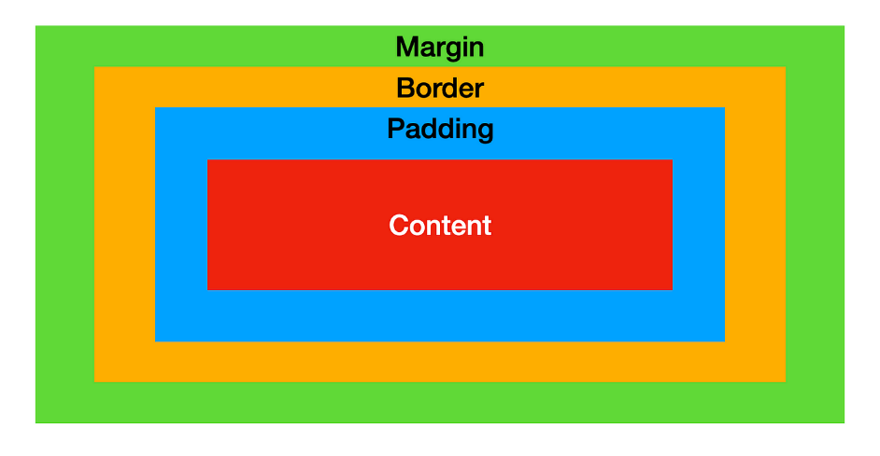
- Margin: The outermost layer. Useful for separating the element from its neighbors. The dimensions are given by the margin-box width and the margin-box height/length.
- Border: The layer between the margin and padding. Its dimensions are given by the width and height of the border. This is the element that is often given a
Visible border

- Padding: The layer between the content and within the border box. Its dimensions are given by the width and height of the padding box.
- Content: This consists of the actual content of the elements such as text, images, or any other media. It’s bounded by content edge and its dimensions are given by content-box width and content-box height.

Common CSS Properties
- There are many properties that can be styled with CSS. Some include:
  - Padding: Gives space between content and its border
    - We can pad top/right/bottom/left of an element
    - Giving the generic padding with numbers will shorthand the filling out of these options:
      - 1 number: all four sides {padding: 70px;}
      - 2 numbers: first number is the top and bottom, the second is right and left {padding: 35px 70px;}
      - 3 numbers: first number is the top, second is left and right, 3rd is the bottom {padding: 25px 45px 70px;}
      - 4 numbers: first number is the top, 2nd is the right, 3rd is the bottom, 4th is left {padding: 25px 45px 70px 80px;}
  - Border: Wraps an element with a border between its padding and margin
    - Border width
    - Border style (dashed, dotted, no border, etc.)
      - Default border style is no border. You must specify to see it
    - Border color
  - Margin: Similar to padding, but outside of the border
    - Separates an element and its box from neighboring elements
  - Display: Determines whether it’s an inline or block element. The display behavior
  - Position: Determines where on the page the element is displayed
    - Static – The element’s box is arranged normally. This is the default.
    - Relative – Defaults to the normal position but can change RELATIVE to the other elements’ positioning.
    - Absolute – The element’s box is placed in an ABSOLUTE position on the page, such as top right or bottom left. When you scroll, it will follow.
    - Fixed – The element’s box is a FIXED location in the window, unaffected by user scrolling or other elements.
  - Color: Allows you to change the color of an element
    - Includes simple options like “red” but you can use rbg, hex color codes, or hsl.
  - Text Align: Sets the text inside the content to be of a particular alignment. I.e. left/right justified, or centered.

CSS Selectors
- “Selectors are how we choose (hence SELECTors) which HTML element to style”
- Element Selectors: Selects all the instances of an HTML element.
p {
text-align: center;
color: blue;
}

- ID Selectors: Selects elements by the ID attribute. IDs should be unique. Uses the # to select. Better for individual elements.

#div1 {
text-align: center;
color: blue;
}

- Class Selectors: Will style any element with the declared class attribute. Uses the “.” to select. Can be combined with an element selector! Better for groups of elements.

.intro {
text-align: center;
color: blue;
}

p.intro {
text-align: center;
color: red;
}

- Universal selector – selects everything. Uses the *
#div1 {
text-align: center;
color: pink;
}

// FOR QC, you can probably just know the above 4 selects and be fine. Just be good on their syntax and use cases. The rest of them below are nice to know if you want more advanced styling.
- Attribute Selector – Allows you to select elements that declare a specific attribute. Uses the [] to select.
[title] {
text-align: left;
color: blue;
}
[class=”warning”] {
color: green;
}

- Grouping Selectors: you can group multiple selectors and apply the same style. Simply declare the selectors and separate them with a comma.

H1, #para1 {
text-align: left;
color: red;
}

- Child Selectors – Selects specific elements that are direct children of another specific type of element. Uses the > sign.
div>p {
text-align: left;
color: red;
}

- Descendant selectors – like a child selector but will affect every element under the “parent” element no matter how far down it is nested. It uses an empty space character between the parent and the decadent.
Div p {
text-align: left;
color: red;
}

- Sibling Selectors – selects an element that is a direct sibling to another element. Uses the ~ to select.

Div~p {
text-align: left;
color: red;
}

- Parents and Siblings??
  - <div id=”mydiv”>
    - <p> This is a direct child of mydiv</p>
    - <div>
      - <p>this is a descendent of mydiv but not a direct child</p>
    - </div>
  - </div>
  - <p> This is adjacent sibling of mydiv</p>
- Conflicts? If selectors conflict with each other, then the “winning” CSS is determined by specificity.
  - ID wins over everything
  - Class beats anything over ID
  - Element is the lowest priority
  - If specifically, does not resolve the conflict, the determination is made by the order of declarations. The latest declaration declared will win.

Bootstrap
- Why write your own CSS when you can STEAL someone else’s? Bootstrap basically lets you do this. It’s an open-source framework with a “mobile first” design approach. Bootstraps and other styling libraries are used pretty much everywhere.
- It uses HTML 5 and CSS 3 to give predefined styling to web pages. This styling is capable of being resized and displayed on any screen.
- Bootstrap can be added to your webpage in two main ways:
  - You can download it directly from getbootstrap.com
  - You can simply use a link to tag to the bootstrap CDN in your <head>
  - Linked here for convenience
    - <link href=”https://cdn.jsdelivr.net/bootstrap@5.2.0-beta1/dist/css/bootstrap.min.css” rel=”stylesheet” integrity=”sha384-0evHe/X+R7YkIZDRvuzKMRqM+OrBnVFBL6DOitPri4jfHxaWutUpFmBp4vmVor”crossorigin=”anonymous”>

Bootstrap Grid System
- Bootstrap uses a layout called the grid system. It consists of containers which contain rows, which themselves contain columns. This layout will be responsive to window size changes if used correctly.
  - This is how we achieve responsive web design. It’s RESPONSIVE to window size changes.

- Containers are the basic layout element used to wrap the content of a web page. There are two container classes:
  - Container – responsive fixed-width container
  - Container-fluid – full width container that spans the entire viewport.
    - A viewport is a region of the screen used to display a portion of the total image to be shown. It sizes the screen to match the screen size of the user.

- Rows are horizontal slices of a container. They are created with the “row” class. Rows have a base size of 12 (the typical width of a webpage).

- Columns have a dynamic width determined by their size relative to the size of the row in the container’s view.
- Columns can be assigned to size. If the size of the columns exceeds 12, the column exceeding the size will be moved below the columns that do not.
  - So, we can have a 3, a 3, and a 6, and they’d all print inline
  - class=”col-sm-3” col is for column, the sm (small) represents the default size of the column, and the 3 id the relative size compared to the row’s size of 12.

Common Bootstrap Styled Elements
- Bootstrap has many classes to style all sorts of HTML elements
- Bootstrap Tables are predefined styling for tables that can be declared again by class.
  - class=”table table-dark” creates a table with a dark background
  - Table-bordered = add a border around the table
  - Table-striped = adds zebra striping to the table
- Bootstrap has a bunch of button classes that let you color your buttons. E.g. btn-danger will give you a red button.
- Bootstrap has a navbar class associated with styling navbars.
- MANY more which I’ll try to show here and there. This is the entire list of them: https://getbootstrap.com/2.3.2/components.html

